1. Java Priority Queue
#code;
import java.io.*;
import java.util.*;

// 1. Student Class Implementation
class Student {
private final int id;
private final String name;
private final double cgpa;

public Student(int id, String name, double cgpa) {
this.id = id;
this.name = name;
this.cgpa = cgpa;
}

public int getID() {
return id;
}

public String getName() {
return name;
}

public double getCGPA() {
return cgpa;
}
}

// 2. Priorities Class Implementation
class Priorities {
public List<Student> getStudents(List<String> events) {

// Custom Comparator based on the problem's sorting criteria
Comparator<Student> studentComparator = new Comparator<Student>() {
@Override
public int compare(Student s1, Student s2) {
// Criteria 1: Highest CGPA first (Descending)
if (s1.getCGPA() != s2.getCGPA()) {
return Double.compare(s2.getCGPA(), s1.getCGPA());
}
// Criteria 2: Alphabetic order by name (Ascending)
if (!s1.getName().equals(s2.getName())) {
return s1.getName().compareTo(s2.getName());
}
// Criteria 3: Ascending order by ID
return Integer.compare(s1.getID(), s2.getID());
}
};

PriorityQueue<Student> pq = new PriorityQueue<>(studentComparator);

// Process all individual event strings
for (String event : events) {
String[] parts = event.split(" ");
if (parts[0].equals("ENTER")) {
String name = parts[1];
double cgpa = Double.parseDouble(parts[2]);
int id = Integer.parseInt(parts[3]);

pq.add(new Student(id, name, cgpa));
} else if (parts[0].equals("SERVED")) {
pq.poll();
}
}

// Drain the Priority Queue step-by-step to maintain proper sorted output order
List<Student> remainingStudents = new ArrayList<>();
while (!pq.isEmpty()) {
remainingStudents.add(pq.poll());
}

return remainingStudents;
}
}

// 3. Main Solution Class (Required by HackerRank's environment wrapper)
public class Solution {
private final static Scanner scan = new Scanner(System.in);
private final static Priorities priorities = new Priorities();

public static void main(String[] args) {
int totalEvents = Integer.parseInt(scan.nextLine());
List<String> events = new ArrayList<>();

while (totalEvents-- > 0) {
String event = scan.nextLine();
events.add(event);
}

List<Student> students = priorities.getStudents(events);

if (students.isEmpty()) {
System.out.println("EMPTY");
} else {
for (Student st: students) {
System.out.println(st.getName());
}
}
}
}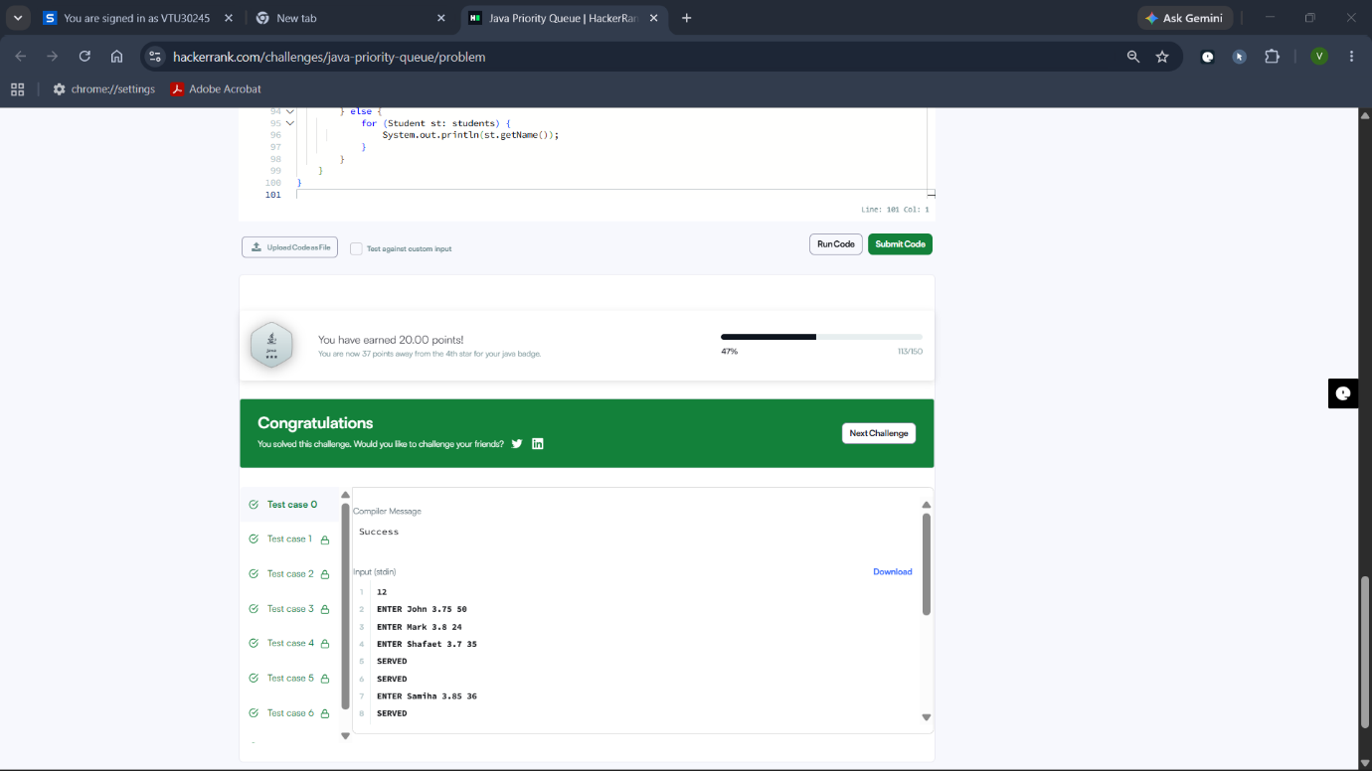
2. Java Arraylist;
#code:
import java.io.*;
import java.util.*;
public class Solution {
public static void main(String[] args) {
Scanner scan = new Scanner(System.in);
// Read the total number of lines
int n = scan.nextInt()
// Create an ArrayList to store each line as an ArrayList of Integers
ArrayList<ArrayList<Integer>> lines = new ArrayList<>();
for (int i = 0; i < n; i++) {
int d = scan.nextInt(); // Number of integers on this line
ArrayList<Integer> currentLine = new ArrayList<>();
for (int j = 0; j < d; j++) {
currentLine.add(scan.nextInt());
}
lines.add(currentLine);
}
// Read the total number of queries
int q = scan.nextInt();
for (int i = 0; i < q; i++) {
int x = scan.nextInt(); // Line number (1-based index)
int y = scan.nextInt(); // Position number (1-based index)
// Adjust to 0-based index for Java
int rowIndex = x - 1;
int colIndex = y - 1;

// Check boundaries safely to avoid IndexOutOfBoundsException
if (rowIndex >= 0 && rowIndex < lines.size() &&
colIndex >= 0 && colIndex < lines.get(rowIndex).size()) {
System.out.println(lines.get(rowIndex).get(colIndex));
} else {
System.out.println("ERROR!");
}
}

scan.close();
}
}

